Automation in AWS
WITH PYTHON(boto3) + LAMBDA + SERVERLESS

AWS Lambda
Event driven:
When a request comes in, AWS allocates resources automatically (based on the configuration we set)
- With the provided resources, Lambda spins up an environment(Light weight container envt) for the function to run
- If multiple requests come, lambda creates multiple envts to run parallely

Lambda layer: an archieved zip file (contains - additional code, runtime, config file,.. )
3 types of Lambda functions:
- Sync Lambda function:- expects response upon trigger
- Async:- no responses here
  - Upon trigger, only function’s action will be performed
- Streaming(real time data)

SDK – Python boto3
- To integrate AWS services
- Boto3 has 2 level of APIs:
Client API – provides low level interface to the service
eg: s3 = boto3.client(‘S3’)
Resource API – provides higher level abstraction comparing to client
eg: s3 = boto3.resource(‘S3’)

Create a function in lambda: Step by step guide:
- Create lambda function through console
- Set timeout >= 1min
- Setup IAM role
  - By default the function created will have access to cloudwatch logs(by default lambda will log all the activities in cloudwatch logs)
- Writing function
  - Access the endpoint(service or resource) of required service eg: s3 = boto3.client(‘S3’)
  - Then use the function of the service
    - Code from here onwards…

Event Bridge
Bridge used to trigger lambda function when any event(both external events and AWS service events included) occurs

API Gateway
4 types of APIs:
- HTTP API(low cost + low latency)
- REST API = HTTP API + some more features
  - Includes: API keys, Request validation, WAF integration
- Private REST API – can be accessed from resources within VPC only.
  - Those requests are routed through VPC Endpoints
- WebSocket API – persistence connection

Authenticating requests
From other services/cross accounts
- Authenticated through IAM Role & Policies
From external users(Outside the trust Boundary)
- Authenticated through Auth tools – Cognito from AWS

Cognito – Authenticating user requests
- Cognito contains user pool which verifies user and send tokens to user(client).
- The requests to API Gateway are made with the token included, then API Gateway authenticates the user with the token.

API Integration & Private APIs
Private APIs – API Gateways live in it’s own VPCs not in client environment VPC

Serverless Architecture Use case 2 – Read Data from S3
Read object from S3 dynamically based on the parameters passed on the request query.
On API Gateway: Reads the input parameters from the request query:
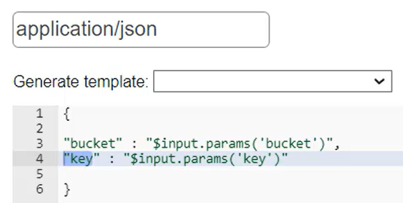

Lambda Function: lambda_handler function takes input parameters from the request query.
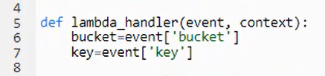

Usage Plan can be associated with the API Gateway to limit throttling, rate limiting
- Used to classify users based on plans –
  - Basic plan with 5 reqs/s and 50 reqs/day
  - Premium plan with 10 reqs/s and 1000 reqs/day
API keys should be specified in the User request directing the request to the respective API Gateway.

AWS Services (Learnings)

DynamoDB
- NoSQL – Schemaless -> which makes it easy for scaling and updating data
- [Fully managed(serverless), automatic scaling] – taken care by AWS
- ms latency
  - best for real time applications
- regionless
  - best for Global applications
DynamoDB in AWS
DynamoDB table is split across multiple partitions(storage nodes) when data grows
- the partition id (primary id) is used to identify which partition the data belongs to

